Keegan Smith

ADS

HW1

9/24/23

1. PMOS Length: 65n PMOS width: 130n

NMOS Length: 65n NMOS width: 130n

1. You can see the addition of the .model functions for the oxide layers in the snippet below.

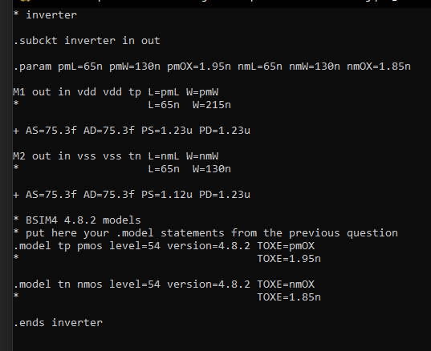

1. In the snippet above you can see the addition of the oxide layers and the other components of the .cir file for the inverter.
2. Below you can see the output of the original circuit model. You can see the graph is shifted towards Vss.

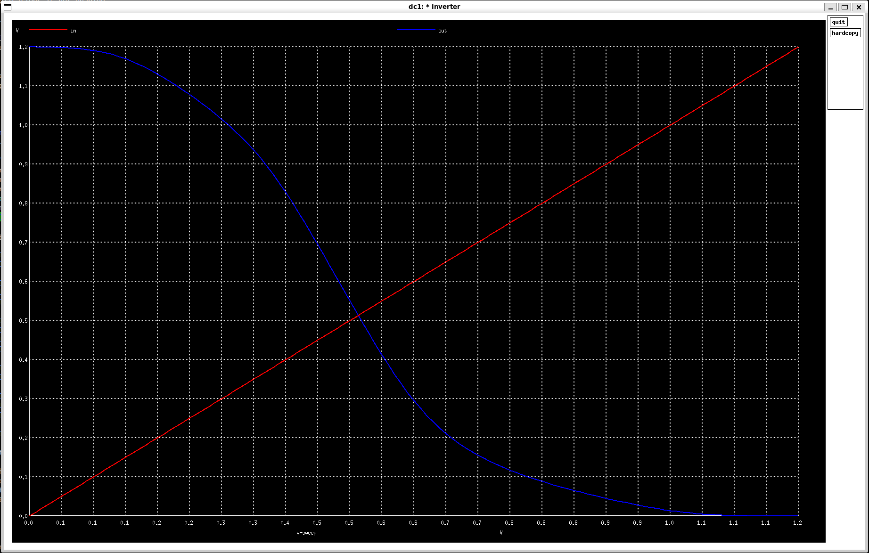

1. Here, you see the intersection on the graph is centered. You can also see that it took the PMOS width being 215n meters to get the lines to intersect at 0.6v.

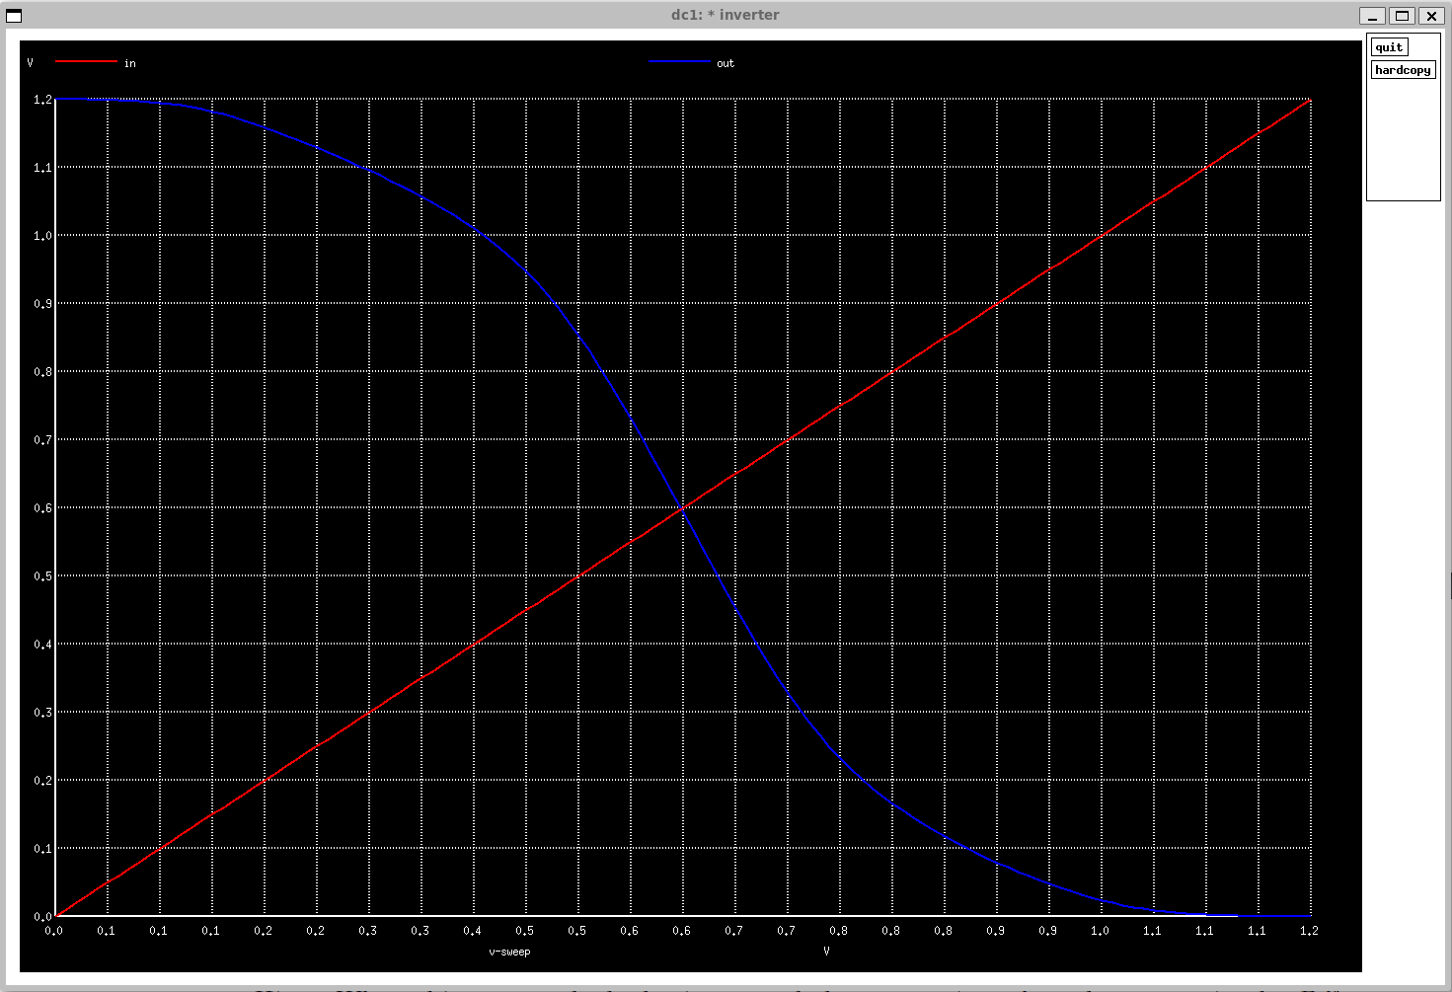

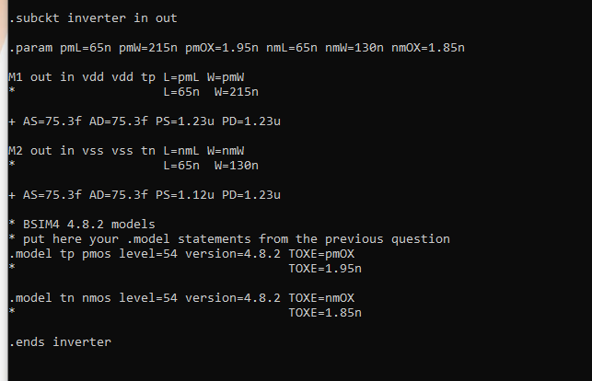

1. AS: Source diffusion area,

AD: Drain diffusion area.

PS: Perimeter of the source junction, including the channel edge.

PD: Perimeter of the drain junction, including the channel edge.

The diffusion areas are to create a transition from the heavily doped areas to lightly doped ones. This creates the channel that allows the transistor to function.